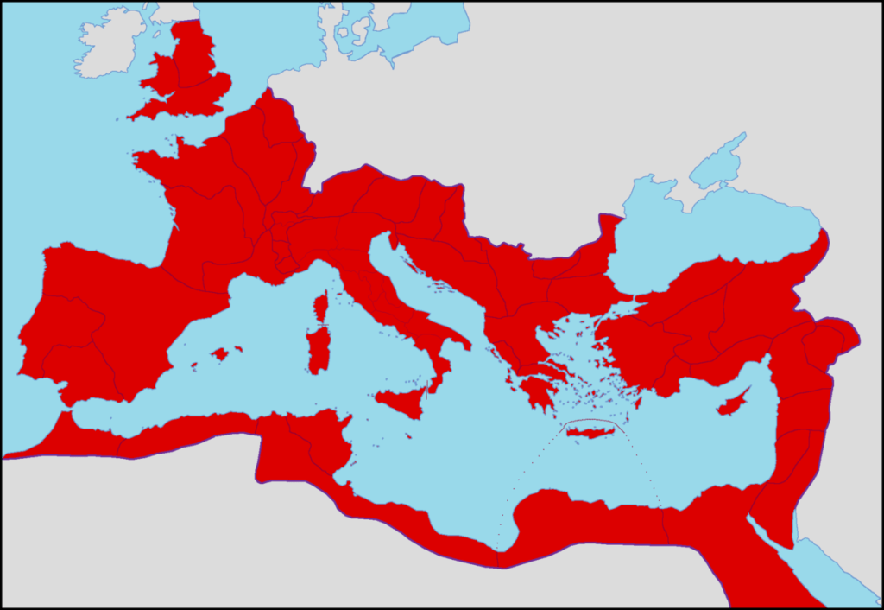

BRITAIN

GAUL

ITALY

- Rome
SPAIN
- Athens
- Antioch
- Ephesus
- Gades
SYRIA
- Carthage

MAURETANIAa
- Alexandria

EGYPT

WHERE ON THE MAP… (Have symbols)
Can you draw the symbols or write the code for where you think these items were traded by the Roman Empire?
- Grain (G) was traded SOUTH of Carthage and SOUTH of Alexandria
- Marble (Ma) was traded slightly SOUTH of Athens, slightly SOUTH and NORTH of Ephesus, WEST of Carthage, in the NORTH of Italy, and on the islands EAST of Spain.
- Metals (Me) were traded in the NORTH-WEST of Gaul, the NORTH-WEST of Spain, on the EASTERN border between Spain and Gaul, to the far NORTH and far NORTH-EAST of the country where Athens is, and NORTH-EAST of Antioch, slightly NORTH-EAST of Ephesus.
- Olive oil (O) was traded in the SOUTH of Spain, WEST of Alexandria and on the island WEST of Syria.
- Textiles (Tx) were traded in the WEST of Gaul, the NORTH of Italy, slightly SOUTH of Antioch and in the SOUTH-EAST of Egypt.
- Timber (Ti) was traded in the NORTH of Mauretania, SOUTH of Antioch, NORTH-EAST of Ephesus, and on the island to the WEST of Syria.
- Wild animals (Wa) were traded in the area EAST of Syria, BETWEEN Mauretania and Egypt, in the NORTH and the WEST of Gaul and NORTH of Athens.
- Wine (Wi) was traded in the NORTH-EAST and SOUTH of Gaul, and the NORTH and EAST of Spain.
- There was a slave trade (S) slightly SOUTH-WEST of Carthage, and the NORTH-EAST area above Athens.

Which of these items do you think the Romans would have found in Iron-Age Britain?

- Wool - Metals (tin, copper, iron etc.) - Gold and silver
- Silk - Coal - Livestock (sheep/ cows etc.)
- Olives - Diamonds - Timber
- Lemons - Salt - Cotton
- Grain - Pottery - Tea

ANSWERS

BRITAIN

Wa
Me
Wi
Tx
Wa
Tx
GAUL
Ma
Me
Me
Wi
Wi
Me
ITALY
S
Ti
Me
Wi
Ti
Me
- Rome
SPAIN
Wa
Ma
Ma
- Athens
O
Ma
- Antioch
- Ephesus
- Gades
Ma
Ti
Tx
O
Ma
- Carthage
S
Ti
SYRIA
Wa
G
MAURETANIAa
O
- Alexandria
Wa
G
Tx
EGYPT

WHERE ON THE MAP… (Have symbols)
Can you draw the symbols or write the code for where you think these items were traded by the Roman Empire?
- Grain (G) was traded SOUTH of Carthage and SOUTH of Alexandria
- Marble (Ma) was traded slightly SOUTH of Athens, slightly SOUTH and NORTH of Ephesus, WEST of Carthage, in the NORTH of Italy, and on the islands EAST of Spain.
- Metals (Me) were traded in the NORTH-WEST of Gaul, the NORTH-WEST of Spain, on the EASTERN border between Spain and Gaul, to the far NORTH and far NORTH-EAST of the country where Athens is, and NORTH-EAST of Antioch, slightly NORTH-EAST of Ephesus.
- Olive oil (O) was traded in the SOUTH of Spain, WEST of Alexandria and on the island WEST of Syria.
- Textiles (Tx) were traded in the WEST of Gaul, the NORTH of Italy, slightly SOUTH of Antioch and in the SOUTH-EAST of Egypt.
- Timber (Ti) was traded in the NORTH of Mauretania, SOUTH of Antioch, NORTH-EAST of Ephesus, and on the island to the WEST of Syria.
- Wild animals (Wa) were traded in the area EAST of Syria, BETWEEN Mauretania and Egypt, in the NORTH and the WEST of Gaul and NORTH of Athens.
- Wine (Wi) was traded in the NORTH-EAST and SOUTH of Gaul, and the NORTH and EAST of Spain.
- There was a slave trade (S) slightly SOUTH-WEST of Carthage, and the NORTH-EAST area above Athens.

Which of these items do you think the Romans would have found in Iron-Age Britain?

- Wool - Metals (tin, copper, iron etc.) - Gold and silver
- Silk - Coal - Livestock (sheep/ cows etc.)
- Olives - Diamonds - Timber
- Lemons - Salt - Cotton
- Grain - Pottery - Tea

