Roman Coins
- Roman coins were useful for seeing what the Emperor of the time looked like, as they showed a profile (side view) of his face. Sometimes, the coins would also have important buildings (such as temples) or animals on.
- The other side of the coin was useful too! It showed the date the coin was made – in Roman numerals, of course.

Using the information above, draw your own Roman coin! Use the numerals to help you write either today’s date or your birthday on the other side.

FRONT: Your head (side view), your friend’s head, a building OR an animal.
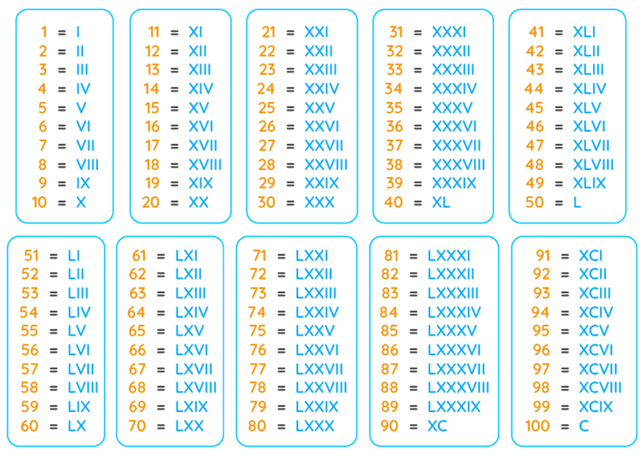
1000 = M
2026 = MMXXIV
2019 = MMXIX etc.
1985 = MCMLXXXV
BACK: The date OR your birthday. Don’t forget the year! You can use the numerals below.

