Create your own heraldry
Your heraldry shows who you are to the people fighting on your side… and your enemies! Create your own heraldry. You might want to use some of the symbols in the gallery to help you.

You might want to think about:
- Whether you would include shapes or animals on your shield
- What colours you would use
- Who you would be fighting for
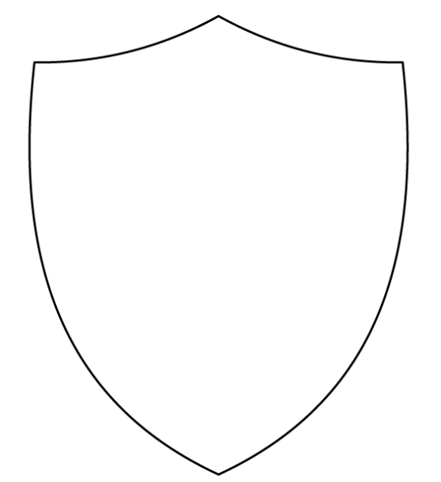
- Where you come from (the town, city or country)

