

**Bosworth Battlefield Heritage Centre and Country Park Accessibility**

**Guide 2023**

Bosworth Battlefield Heritage Centre is set in the heart of England near Sutton Cheney, a picturesque village in gentle rolling countryside.

It is important to us to share as much information as possible before your visit. We want you to have the best experience over the weekend.

If you have specific questions or ideas, please do get in touch with us at [bosworth@leics.gov.uk](https://www.bosworthbattlefield.org.uk/). Please do share your ideas and what you need in place to make your visit the best experience possible.

Our team will welcome you on site.

We will be wearing burgundy-coloured tops or lanyards around our necks.

We look forward to meeting you.

**Where to Find Us**

Bosworth Battlefield Heritage Centre and Country Park is accessible by road and via the Battlefield Railway line www.battlefieldline.co.uk

Follow this link for a list of local services:

[www.bosworthbattlefield.org.uk/local-services](http://www.bosworthbattlefield.org.uk/local-services)

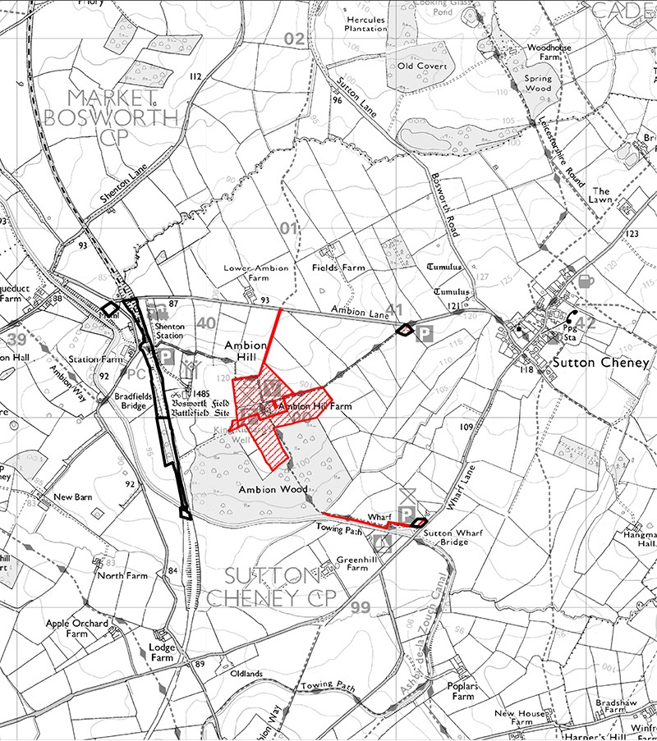

**By Foot from Market Bosworth**

Take the gated road that is just below the marketplace. This goes out of Market Bosworth and is signposted Sutton Cheney. Then take a right onto Ambion Lane and walk another half a mile and look for the signpost mentioning the Centre

**By Car**

Surrounded by a network of motorways, the M1, M6, M42 and only 9.5 km from Jct 1 on the M69. Located close to Market Bosworth, 5.5 km North from Hinckley and only 19 km from Leicester. Post code CV13 0AD.

**By Bus**

Catch the 153-bus service (does not run-on Sundays) from Leicester to Market Bosworth. The Heritage Centre and Country Park is located three miles south of Market Bosworth. Taxis are available although they do need to be pre-booked, or you could take a pleasurable walk. www.arrivabus.co.uk

**By Rail**

Regular services are available from London to Nuneaton and Leicester. www.nationalrail.co.uk

**By Canal**

You can visit us from The Ashby Canal. There are some 48-hour visitor moorings by Sutton Cheney Wharf. Visitors can follow the footpath up to the visitor centre.

There are moorings by the old railway bridge 34A, follow the old line up to Shenton Station and on to the visitor centre that way.

**By Air**

Accessible from either East Midlands Airport or Birmingham Airport.

If you need help planning your journey, please do get in touch.

**The Country Park**

You can explore the country park by following our network of surfaced trails. The trails are undulated and take you along the farmed landscape, the Ashby Canal, and the Battlefield Railway at Shenton Station.

The Battlefield Trail is 2.2km (1.23 miles). You will see panoramic views over the Battlefield landscape. You will find audio and visual information available on the trail.

A map is available to download from our website or you can pick one up from the ticket office on arrival.

We have an off-road mobility scooter available free for hire, please call 01455 290429 for more information.

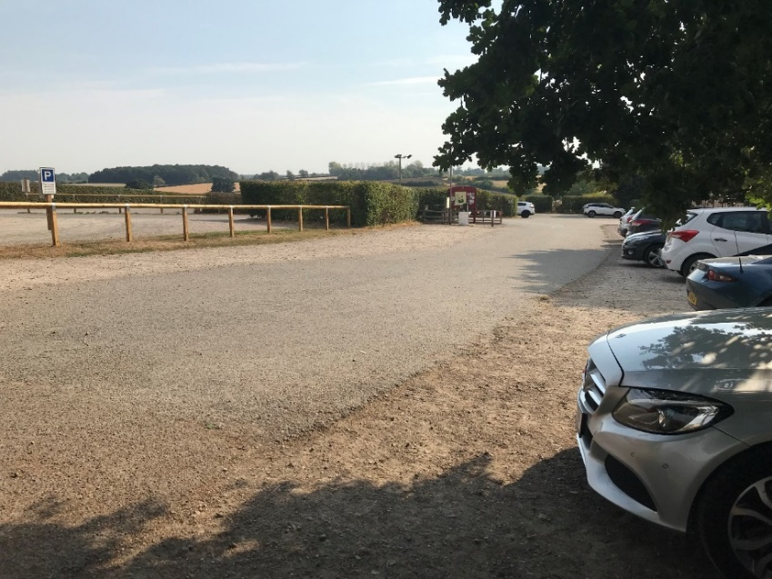**The Car Park**

Our car park has a gravel surface.

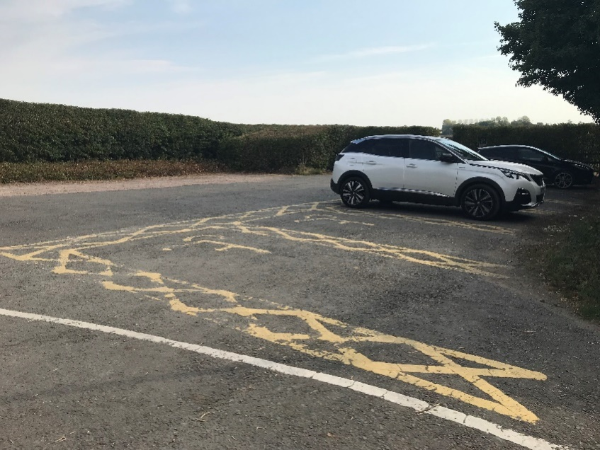

We have a designated blue badge car parking area which is signposted.

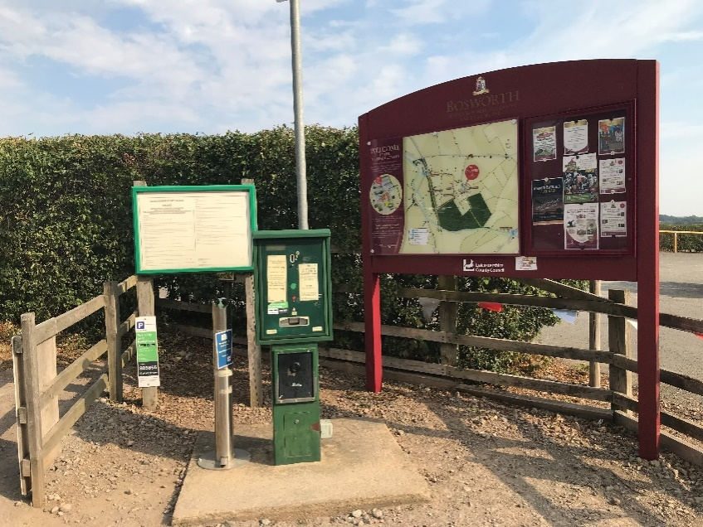

Car parking is £2.50 per car.

Payment can be made by either-

* ‘cash only’ pay machine
  + - * ‘cash/card’ in the Ticket Office

or shop located in upper

courtyard

* + - * PayByPhone App

**Bosworth Battlefield Heritage Centre**

The site of the Battle of Bosworth is nationally and internationally significant.

It is the place where King Richard III lost his life and his crown to Henry Tudor. This was the start of the powerful Tudor dynasty.

Our exhibition shares this story.

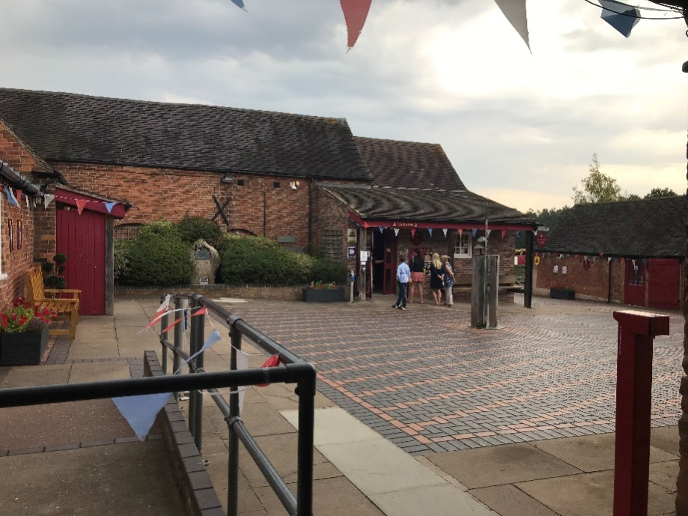**The Upper Courtyard**

The Centre is around a paved courtyard as you enter the site.

You will find the toilets, accessible toilet, information desk, exhibition, and shop here.

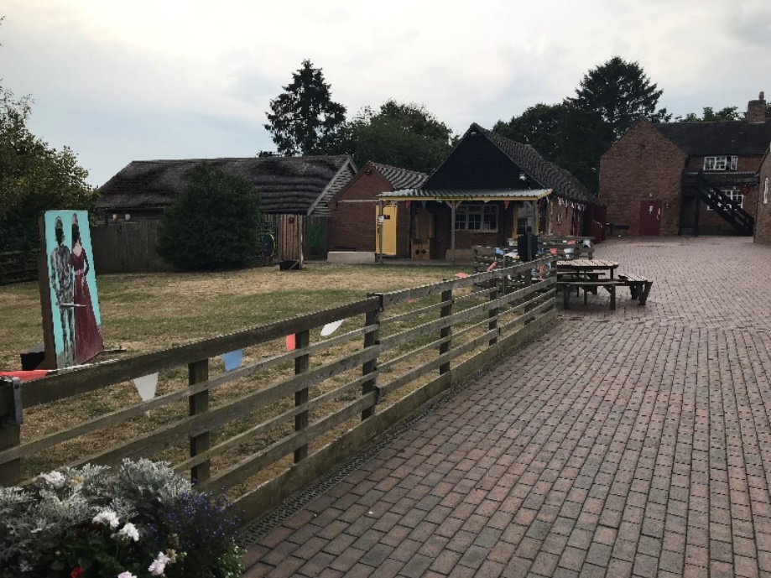**The Lower Courtyard**

Here you will find the Discovery Zone for younger children which is open at set times through the year.

**The Exhibition**

Entrance to the Exhibition is fully accessible for wheelchair users.

The main door is automatic.

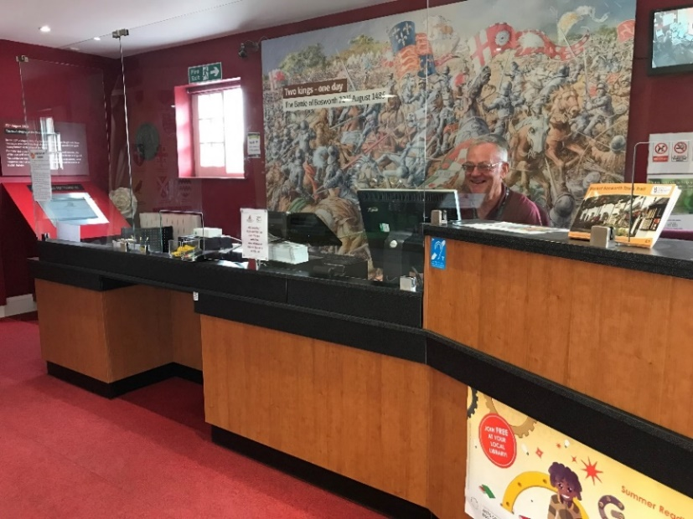

Our staff will greet you and issue you a ticket.

Our exhibits are hands on and for all ages.

If assistance is required, please speak to a member of the team.

Some areas can be dark with images of the re-enactment of the battle.

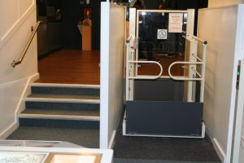

We have an access lift within the exhibition which will take you from the exhibition and into the shop.

**Gift shop**

At the end of the exhibition you will find our Gift Shop, this is accessible via a platform lift at the end of the exhibition or via a ramp from the upper courtyard.

Our shop sells a wide range of gifts, books and souvenirs suitable for all ages.

Our staff are on hand throughout the site if you have any questions or concerns.

**1485 Tithe Barn Restaurant**

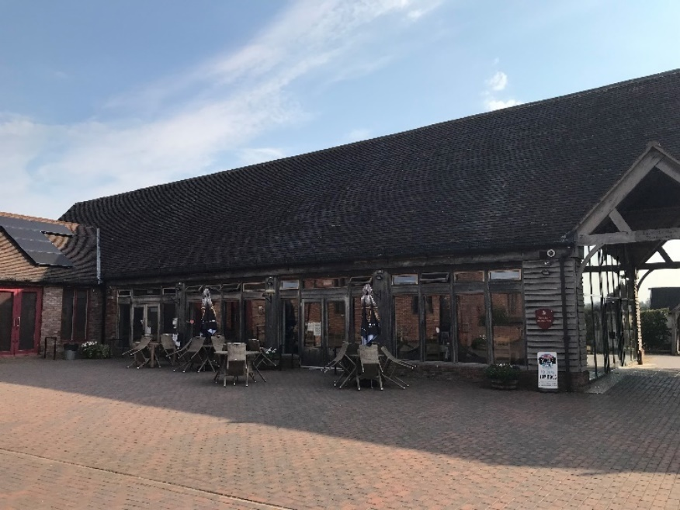

The 1485 Tithe Barn Café is open Wednesday – Sunday, entrance is accessible via the lower courtyard and is fully accessible for wheelchair users.

The main door is automatic

There will be all day breakfast, bacon, and sausage sandwiches.

Jacket potatoes and pastries.

Selection of sandwiches.

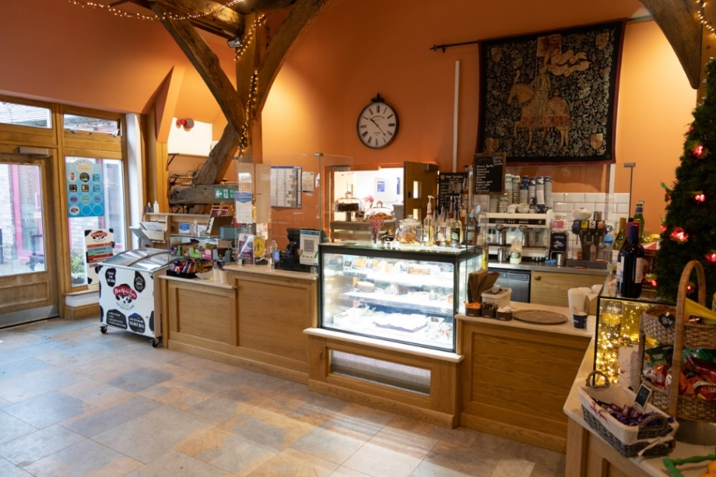

Cakes, snacks, and drinks available.

A children’s menu with chips, nuggets, and fish fingers.

Vegetarian and vegan options.

Hot food will be served till 2pm.

All the above is subject to availability

**Accessible Toilets**

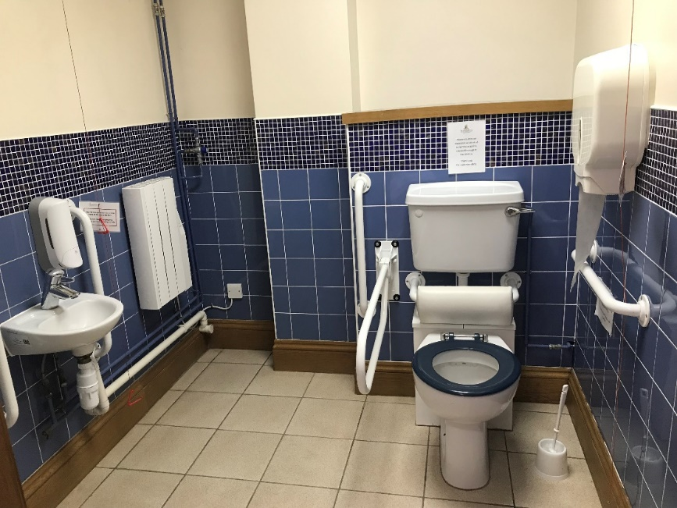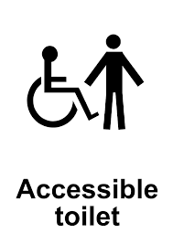

We have two accessible toilets which are in the Upper and Lower courtyards

**Where to sit**

We have ample seating within the courtyards.

**Additional Information**

**Access **

Access from the car park to the Heritage Centre is slightly inclined and is covered with loose gravel.

* There is level access within the courtyards.
* There is level access to the toilets within the courtyards.
* There is level access to the Tithe Barn Restaurant.
* There is level access to the entrance of the Exhibition
* Access to the shop is via a ramp in the Upper Courtyard
* Automatic doors are situated at the entrance of the Tithe Barn Restaurant and Exhibition.

**Hearing**



* A hearing loop is situated at the admissions desk of the Exhibition

**Visual**

* Some parts of the venue have low lighting
* Exhibition- we have information is BSL, and transcripts in a range of languages.

**General**

* We have a complimentary ticket policy for carers

This document has been updated, if you have any comments or suggestions on what should be included, please contact us on the email below.

**Trail Map**

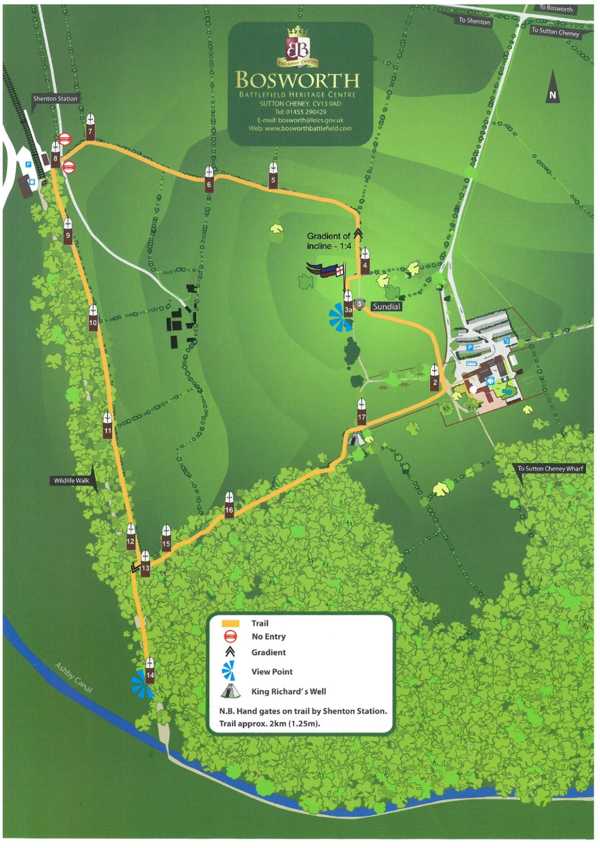

**Website**

www.bosworthbattlefield.org.uk

**Telephone**

01455 290429

**Email**

bosworth@leics.gov.uk

**Address**

Bosworth Battlefield Heritage Centre & Country Park, Sutton Cheney, Nuneaton, CV13 0AD