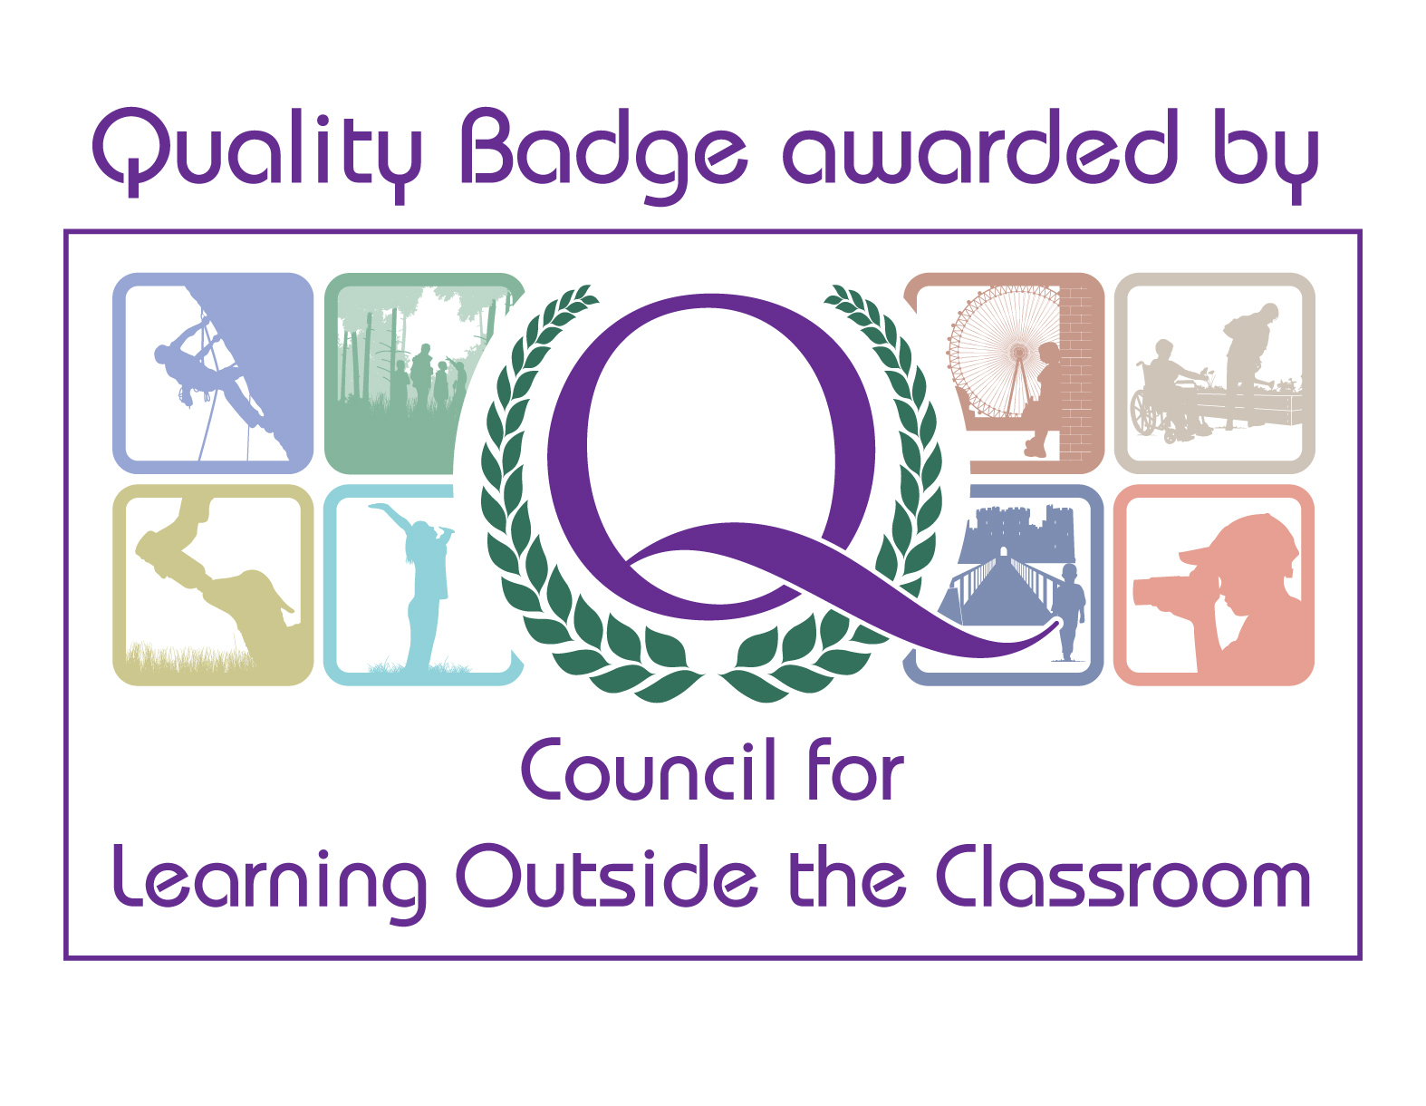

COVID-19 Procedures for school sessions delivered
at Bosworth Battlefield Heritage Centre

KEY PRIORITIES
Minimising contact with individuals who are unwell by ensuring that those who have coronavirus (COVID-19) symptoms, or who have someone in their household who does, do not attend work
Promoting good respiratory hygiene by promoting the ‘catch it, bin it, kill it’ approach
Introducing enhanced cleaning, including touched surfaces, objects, equipment and hands
Keeping a 2-metre gap between the school party and the facilitator throughout the visit
Facilitators, site staff and school party wearing PPE equipment when necessary

WE HAVE CONSIDERED:
The number of people that can reasonably follow social distancing at the centre considering total space, equipment as well as likely constraints and pinch points
The ventilation, which activities can be undertaken, and which spaces can be used with specific measures to ensure social distancing and maintain cleaning
The number of people on site overall and specifically in congested areas near doorways and inside spaces

IMPORTANT INFORMATION PRE-VISIT:
One school party (bubble) allowed onsite per day. Due to COVID-19 the number of pupils we can accommodate has reduced. Please discuss numbers with our Sales and Enquiries Team. We have reduced our numbers to keep all school parties, facilitators and site staff safe
A ratio of 1 adult to 10 pupils is needed to support all bookings
Please note that adults within the school party cannot socially distance themselves from their pupils due to the restricted space available in some locations and because of health and safety/safeguarding reasons, so the adults must be a part of the same bubble

School should communicate any relevant details to sales and enquiries – including all SEND information so that the facilitators and staff can tailor their sessions towards your needs and so they know to add extra COVID-19 measures if necessary. If you cannot fit all of this information on the booking form – please email Sales and Enquires directly with this information – bosworth@leics.gov.uk
Please be aware that we have had to make some small tweaks to our sessions in line with Covid-19. We however are still dedicated to providing a high-quality learning experience
For the time being school parties cannot use the shop, but our gift packs can be pre-ordered before the visit. Please ask Sales and Enquires for more details – bosworth@leics.gov.uk
Those who are 11 years + within the school party are to wear a face mask in the exhibition and shop areas (unless exempt). The facilitators will wear a visor when delivering all sessions inside the exhibition and in other indoor spaces when appropriate to do so. They will wear a face covering in the shop and ticket office when they are not delivering their sessions

When a school books either the Guide-Led Tour of the Exhibition Session or the Self-Led Tour of the Exhibition session – they will be given full access to the exhibition space without any other members of the public sharing the same space
Schools must guarantee that, to the best of their knowledge, there are no symptomatic pupils and adults present during sessions
The mobility scooter can be hired for 2 hours. But as it needs to be quarantined for 72 hours between use – its availability may be limited. Pupils can only use the mobility scooter if they are 16 years plus and the school needs to pre-book the scooter at booking stage
There are First Aid trained staff onsite, but all school parties are responsible for their own first aid
All activities have been fully risk assessed, please read the School’s Risk Assessment
If further restrictions are imposed locally or nationally, then school visits will be cancelled without a cost to the school
If the facilitators are not able to deliver at last minute due to illness, the centre will do all it can to find a replacement. If the centre cannot book a replacement for the day of the visit, the centre will need to work with the school to change the date at no additional cost to the school

ON THE DAY
Following the latest government guidelines all school participants who are16/over, which includes teachers, pupils and additional support staff, who visit our Heritage and Museum sites, are now required to leave their personal contact details for track and trace. The contact details of your group will be kept in a secured location for 21 days, after 21 days the contact details will be destroyed. In order for us to have your up to date information we are asking you to complete the form and hand in to the member of staff who meets and greets you on your arrival at the site. The form is available on the website - https://www.bosworthbattlefield.org.uk/learning/learning-resources/
On arrival to the site the facilitators will sanitise/wash their hands. Hands will also be sanitised between sessions and after handling any object touched by the school party
The school party will also need to sanitise/wash their hands-on arrival and after each session. There is hand sanitiser available in specific locations onsite, but all school parties also need to bring their own
To clean your hands, you should wash your hands thoroughly for 20 seconds with running water and soap and dry them thoroughly or use alcohol hand rub/sanitiser ensuring that all parts of the hands are covered.
Avoid touching your mouth, eyes and nose. Cover your mouth and nose with disposable tissues when you cough or sneeze. If one is not available, sneeze into the crook of your elbow, not into your hand. Dispose of tissues into a disposable rubbish bag and immediately clean your hands with soap and water or use a hand sanitiser.

When a school party arrives onsite, they will be fully briefed and then supported throughout the day
All school parties will be briefed on arrival to support the visit
For SEND groups – staff and facilitators will do all they can to verbalise signs when possible and provide extra support for the group to keep to the social distancing guidelines, as we are aware that it can be harder for these groups to maintain a 2-metre distance from other visitors
Facilitators will give short briefings at the start of every session – to communicate briefly any measures that will directly affect the group
The facilitators are to keep a 2-metre distance between themselves and the school party throughout the visit
The school parties are to keep a 2-metre distance from other bubbles on site (other general visitors), from the facilitators and site staff
School party/bubble to use the set of toilets and the disabled toilet (if needed) nearest to the main office. Toilet sessions are to be managed by site staff to ensure that no other visitors use these toilets at the same time and so all touchable surfaces are cleaned after use. If a site member of staff is not with the group, then the school party need to ask for assistance from the main office. Otherwise the school party are to follow the public guidance when accessing the toilets, which is currently 1 in, 1 out
Individuals within the school party, who are 11 years +, have to wear face coverings in the exhibition and shop areas (unless exempt)
The responsible adults need to ensure that they are put on correctly and removed, stored and disposed of correctly to avoid inadvertently increasing the risks of transmission
Site staff will wear face covering when inside and when engaging with the public and the facilitators will wear face coverings only when inside and only when necessary to do so
When handling objects during a session, the school party will take these from a receptacle or table, rather than the facilitator, so that they can keep the required distance
The facilitator will only touch an object, touched by pupils/school staff, if they are cleaning it or are wearing gloves
All objects, seating, storage boxes and equipment will be cleaned by the facilitator after each session or at the end of the day. It may be that some objects are quarantined for 72 hours before they are used again if they are not able to be cleaned or if the facilitator/site has duplicates that can be used
The school party is responsible for taking their own rubbish away with them. There are no bins provided in the lunch areas

AFTER THE VISIT
School should notify Sales and Enquiries if a member of the school party (adults and pupils) develop COVID-19 symptoms, in line with the government Track and Trace policy (within 48 hours of the school visit/after the weekend if the visit falls at the end of the working week). The centre will do the same if any member of staff involved in the visit also develops symptoms.

CONTACT INFORMATION
If you have any further questions, please contact Sales and Enquiries on 01455 290429 / bosworth@leics.gov.uk

We are dedicated to ensuring that all school parties have a great visit at the centre.
Please let us know how the visit went. You find our evaluation form on our website https://www.bosworthbattlefield.org.uk/learning/learning-resources/

Enjoy!

