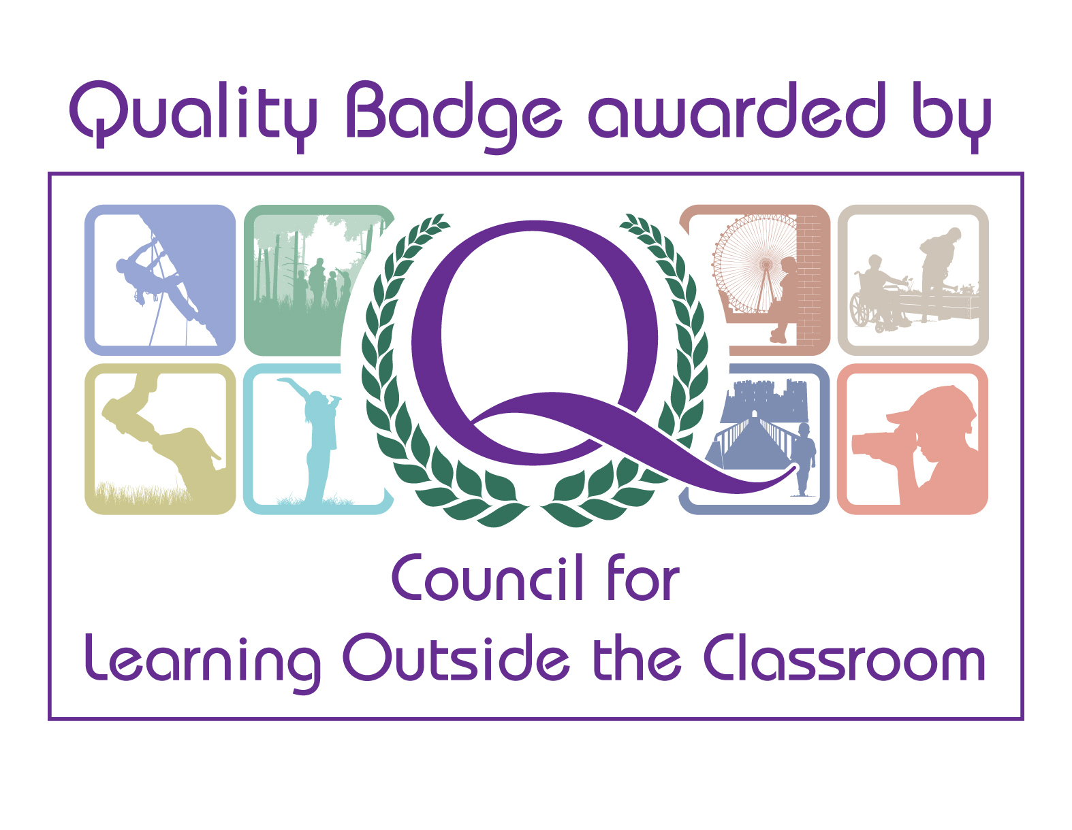

Guide-Led Tour of the Exhibition Briefing for Schools

The below bullet points will help you prepare for the above school session
The exhibition introduces the Wars of the Roses and then tells the story of the battle chronologically. Briefly:
- The exhibition starts with what happened before Bosworth, then shows Richard’s and Henry’s journey to Leicestershire, how an army was organised and how it communicated across long distances
- Then the exhibition introduces the weapons used and clothes worn by the different types of soldiers, takes you to the battle itself through film, shows the work of the Barber Surgeon, explains what happened after the battle and focuses on the dawn of the Tudor dynasty and its legacy
- Then finishes with the most up-to-date stories on the archaeology found locally and what that has taught us about the battle, the finding of Richard III and compares the achievements and the resting places of both Kings

- Before entering the exhibition, we ask that everyone in the group sanitises their hands and puts on a mask if they are 11 years plus (unless exempt) – it has to be a mask and not a visor, for example. There is hand sanitiser just outside the main door
- Once the Guide has finished their first briefing (before your group enters the exhibition) they will guide you through the galleries and brief the pupils on what they can interact with and learn/discover in each of the spaces
- The Guide will give the group clear instruction on where to go so that they can keep a safe distance from your group. Please therefore encourage your class to listen carefully to the Guide so that they are able to get the best out of your pupils
- The Guides will allow the pupils time to explore the galleries and then time to ask questions to reinforce their learning
- The session has been redesigned in light of COVID – so a lot of the discussions will be taking place in the bigger spaces
- The public will not be in the galleries at the same time as the school group

- We’ve had to make some changes in the galleries, such as removing the dressing up, but there are still a number of films and other interactives for your group to enjoy
- The pupils will be able to use a stylus to touch the buttons next to the screens to watch the films. These will be given out by the guide at the start of the session and then collected at the end of the session. They will be kept in quarantine for 72 hours before they are used by another school party
- Other objects and interactives can be touched by hand and some can’t. If the objects can’t be touched there are is a sign articulating this
- Please take care in the Journey to Bosworth Gallery with the Communications interactive
- All touchable surfaces will be cleaned after a school session, but it is really important that your group uses the hand sanitiser to reduce the likelihood of spreading COVID
- There are hand sanitiser stations throughout the exhibition for your school group to use when necessary
- When entering and leaving the exhibition, we ask that everyone in the group sanitises their hands. There is hand sanitiser in the courtyard just in front of the main exhibition door and in the courtyard as you exit the shop at the end of the exhibition
- We also encourage all school groups to use their own hand sanitiser as well to help keep our site costs down

- The Guides are very committed to delivering a great session to be enjoyed by all! Enjoy

Thank you

