Heritage & Museums Service
Leicestershire County Council

REQUEST FOR QUOTATION (RFQ)

LEARNING AND COLLECTIONS RESEARCHER CONSULTANCY ROLE TO INFORM THE MUSEUM AND HERITAGE LEARNING DEVELOPMENT PROJECT JANUARY TO MARCH 2021

Issue Date: 30th October 2020

Return Date: 11th November 2020 12:00 Noon

Background

LCC Heritage and Museums Service has recently been restructured, which has brought together the learning offer for 5 sites under a single officer, to help improve quality across the service. The long-term sustainability of these offers was an area of concern before COVID 19 and is now critically in need of review. A relevant, engaging and high-quality learning offer is a fundamental principal of our service, a key means of sharing our unique stories and generating income.

COVID 19 presents us with a challenge in how we support schools to access our sites and learning programmes. We anticipate that we will see a reduction in the number of school visits if our business model does not respond to a post COVID environment. We therefore urgently need to assess & review the service’s learning programme to maximise the potential of digital engagement, outreach and onsite delivery.

In light of the current restrictions, the Service has commenced a phased recovery for all five sites, with reduced opening hours and a reduced learning offer, which will leave the Service unable to meet its income targets. To address the current challenges, this project, directed by a Steering Group, will work with a series of consultants to undertake a full evaluation of the current offer, and research, evaluate and provide a set of robust recommendations to enable the service to plan a new, sustainable learning offer for the next 3 years. This project is funded by the Arts Council Cultural Recovery Grant, which requires the funding to be spent by the end of March 2021.

The three levels of experienced sector professionals engaged by the project will provide a sound, peer-reviewed overarching business plan, as well as detailed practical recommendations for each site.

In Phase 1 (November 2020 to January 2021) an Independent Advisor will lead a market appraisal of local schools and competitors; an evaluation of our existing learning offer and the creation of an Audience Development plan. The Learning & Collections Researcher will investigate our collections and stories based on the national curriculum and investigate how we make best use of the spaces we have available. This work will be supported by relevant experts from the service team. The outputs of phase 1 will provide the evidence for the Independent Advisor to create an evaluation report, for the service to create a learning strategy, which will then be assessed in Phase 2.

In Phase 2 (January to March 2021) the Consultant will work with the project team to assess the staffing structure and formulate a delivery plan for a blended programme of onsite, outreach and digital delivery, with clear milestones and identified income streams.

The Learning & Collections Researcher will support the above activity within phase 1 and 2, through the co-creation of appropriate session plans that can be delivered on gallery; as outreach sessions and online.

With careful budget management and detailed reporting throughout, the project will put the Service in the strongest possible position to strategically plan a deliverable programme that meets the needs of schools and income targets.

HISTORY OF THE SITES/COLLECTIONS

The strapline for Leicester, Leicestershire and Rutland is ‘Uncover the story’ and we have many local, regional, national and international stories to tell. Each site offers exciting and engaging displays with multiple levels and techniques of telling our stories, although several of these are now made more challenging in the current Covid-19 situation. Each site also has an online presence, either through websites or social media, which enable us to reach a far wider audience.

Bosworth Battlefield Heritage Centre has the most obvious international reach, as the story it tells had a direct impact on national history and an indirect impact on world history. World trade and exploration was sponsored by the winner of the Battle and attempts at colonisation were made under the late Tudors. The story of the search for the Battlefield through systematic archaeological and landscape survey is also told, which at the time was ground-breaking research in the discipline of Battlefield Archaeology, and a model which was followed by others around the world. Members of the Bosworth team are also involved in work on the forthcoming 1485 Sculpture Trail, a highly unusual sculpture trail helping to interpret the wider Battlefield area to visitors from the UK and beyond through chronological storytelling in the landscape. As well as the Battle of 1485, the Bosworth site holds an internationally significant collection from a Roman temple site, which was discovered during the archaeological survey to locate the Battlefield. Both of these elements feature in our learning offer. Bosworth holds the Sandford Award and the LOTC badge.

Harborough Museum tells the fascinating story of its district and has a gallery focused on an Iron Age temple site of international significance at Hallaton, and displays its finds, which include incredible deposits of coins, a Roman cavalry helmet and other high-status objects. Set within the Symington corset factory, it displays examples from this internally important collection curated by the Council.

Charnwood Museum tells the story of the borough including the discovery of Charnia, the world’s earliest fossil, discovered by two school children in the 1950s, which led to the identification of many more Precambrian specimens
around the world. It has displays covering the Auster aircraft, made locally but served in a military capacity around the world; 18th century developments in animal breeding by Robert Bakewell and the pioneering mechanisation of
lacemaking by Heathcote. Another heavily featured locally-based household name is Ladybird Books.

Melton Museum’s stories connect to families that have moved to the USA, Canada and Australia. The household names of Stilton Cheese and Melton Mowbray Pork Pies feature in its rural industry gallery as well as devoting space to the story of hunting in the area, which was a huge influence on the development of the town itself. It also presents the other side of the story, looking at the anti-hunting movement and we feel that this would be an
excellent vehicle for a new learning session.

The 1620s House and Garden is unique in its own right, as a well-preserved example of a late 13th century private house, partly remodelled in the early 17th century by the Digby Family who had a Gunpowder Plot associations. The house is set within early 17th century style gardens, the labels for which make it one of the best interpreted gardens in the country. The 1620s site also holds the LOTC badge.

These Museums are truly inspirational places for all types of cross-curricular learning, but as well as being very distinct from each other, the current learning offer also differs greatly from site to site, from normally very busy and lucrative to virtually non-existent.

Project Definition

Project Objectives

The grant will be used to enable us to undertake a review of our learning offers across all five museum and heritage sites, which will lead to a series of recommendations and actions that we can take forward. This is to ensure that our learning offer continues to meet the needs of schools and other key groups, and that it’s effective and sustainable for the future. The Project will provide the Service with a fully costed plan with which to further develop and deliver a sustainable learning programme at all five sites over the next 2-3 years.
To comply with the terms of the grant, the complete project needs to be concluded by March 2021

Role of the Learning & Collections Researcher, Phase 1 & Phase 2 (November 2020 to March 2021)

The role of the Learning and Collections Researcher is to:

- Investigate the collections and stories in light of the national curriculum at the 5 museum sites
- Outline the key strengths of the collections, identifying how best the collections, stories and the exhibition content can be used to create a new learning offer at each of the sites, with a blend of onsite, outreach and digital delivery.
- Use the evaluation report, created by the Independent Advisor, to further assess the use of the learning spaces and design session plans - taking into consideration the physical nature of these spaces, delivery in schools and a virtual classroom set up, and the key strengths of the collections
- Design session plans that will focus on varying curricular subjects and levels (EYFS level all the way through to university level)

Required skills and experience

The Researcher must have experience of:
- Working on interpretation projects – developing learning sessions with the collections, stories and exhibition displays as the main point of inspiration
- Investigating collections and developing session plans based on the needs of schools and museum/heritage settings
- Working with the curriculum to inform the development of varying learning sessions, with a focus on different curricular subjects and levels (EYFS level all the way through to university level)
- Digital learning delivery
- Working within a local authority framework

And must be skilled in:
- Working to a fixed timescale
- Excellent written and verbal communication skills
- Working effectively with colleagues.
- Writing session plans
- Researching collections and stories from a curriculum perspective

In support of this work, the other external consultancy roles will:
- Evaluate the current learning programmes
- Conduct market research
- Develop key audience development and marketing strategies
- Investigate possible future staffing models
- Formulate a delivery plan for a blended programme of onsite, outreach and digital delivery

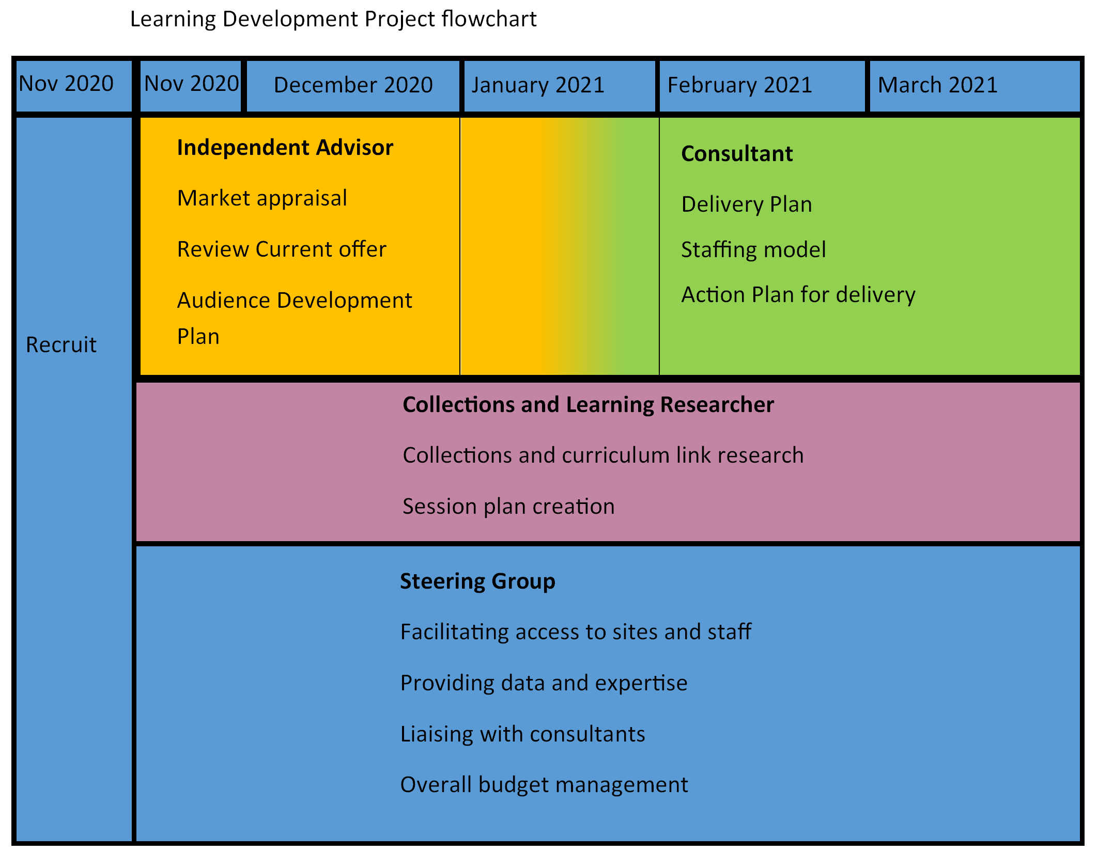

Payment

There are 36 days allocated to this role to be delivered between late November 2020 and March 2021. With a daily rate of £250 this equates to £9,000. This sum includes the post’s travel costs.

Suppliers should indicate their ability to work within the budget detailed above and meet the timescales detailed in the timetable below.

For an informal discussion about the role please contact either:
Richard Knox, Heritage Access & Interpretation Manager
Tel: 0116 302180 / e-mail: richard.knox@leics.gov.uk
or
Melissa Lewis, Heritage Learning Officer
Tel: 0116 3052172 / e-mail: melissa.lewis@leics.gov.uk

This procurement process intends to follow the time-line below:

PROCUREMENT TIMETABLE
Stage | Dates 2020/21
Invitation to Quote issue date | 30th October 2020
Invitation to Quote return date | 11th November 2020 12:00 Noon
Evaluation completed by | 12th November 2020
Online Interview | 18th November 2020
Contract start date | 25th November 2020
Contract completion | 31st January 2021

Please note the Council reserves the right to amend this timetable.

SUBMISSIONS

In line with the Councils Contract Procedure Rules, suppliers are being given the opportunity to quote for the services required. By receipt of this RFQ you have been selected to provide one of the quotations. Should you be interested in providing a quote for this service, you should provide:
• Pricing schedule, detailing all direct and associated costs, which should not exceed a maximum of £12,150.
• Detailed proposal which sets out:
o A description of the organisation / individual(s) involved in the work;
o The experience and skills of those undertaking the work;
o The proposed methodology/approach to undertaking the work;
o The timescale for the work;
o Any relevant examples of any recent work conducted by the organisation;

CVs for the consultants who will be assigned to the project must be included with the proposal.

The Supplier must sign the attached Contract Conditions Acceptance.

The information provided by the Council and output(s) from this consultancy shall be the property of Leicestershire County Council and may NOT be used without the express permission of Leicestershire County Council.

• Payment details (appendix 1)

• Conditions of contract acceptance (appendix 2).

The Council will not entertain material or substantial changes to the issued Contract Terms & Conditions. The final decision as to whether additional/amended terms are permitted will remain with the Council. The types of amendments that the Council is likely to accept may include specific licence requirements. Material changes to the contract will not be accepted. The final decisions to what constitutes a material change will be made by the Council

• Contact Details

Bidders maybe asked to present to Officers of the County Council before a final decision is made.
Quotations are completed offline and should be saved as a document or documents (either word, excel or pdf, as appropriate).
Completed submissions to be received by 12 Noon on 11th November. Quotations submitted after the designated time and date will be rejected.
The Council reserves the right at any time to cease this tendering process and not award a Contract. The Council will not be responsible or liable for any costs, expenses, or losses which may be incurred by the Tenderer in the preparation of this tender and the Council’s decision to cease this tender process.

EVALUATION OF QUOTATIONS
The Council will accept the quotation that is the Most Economically Advantageous Tender (MEAT). This will be assessed based on your response to the pricing schedule with 10% of the evaluation marks available for this element. The remaining 90% of evaluation marks available applies to the detailed proposal.
The Pricing Schedule will be assessed based on the lowest price receiving the maximum 10% available & all other scores being awarded pro-rata a score based on the difference between the tenderers price and lowest tenderers price.
The detailed proposal/bid (90% of marks) will be assessed as defined below:
Proposal / Bid % of Score available
Organisation Details For Information purposes Only
Experience of Organisation and Social Value 60%
Methodology 20%
References 10%

Each of the above sections will be assessed against the following scoring matrix as to how the supporting information meets the requirements outline above.
Scoring Matrix
Section 5, Supporting Information will be assessed on a scale of 0 to 5 points, as detailed in the table below:
0 No response or the response raises major concerns about understanding the requirements or approach which could lead to failure for delivering the review.
1 The response suggests significant shortcomings of understanding the requirements; likely to impact seriously on the quality of the review delivered.
2 The response suggests minor shortcomings of understanding the requirements which may impact adversely on the quality of the review.
3 The response suggests a good understanding of the requirements and methodical approach. The review is likely to be delivered to a good quality. Any concerns are of a minor nature.
4 The response suggests a clear understanding of the requirements and methodical approach. The review is likely to be delivered to a very good quality. No concerns.
5 The response suggests an excellent understanding of the requirements and methodical approach. The review to be delivered shows an approach which will yield maximum benefit. Innovation is shown in the response, exceeding expectations.
Scoring ‘0’ for any section of the supporting information will give grounds for excluding the tender from further consideration.
Following each section receiving a score against the scoring matrix above; this score will then be expressed out of the maximum possible weighting for that section.
Following the evaluation as per above both scores for pricing schedule and proposal will be added together to give a total score out of 100%. The highest scoring tenderer will then be awarded the contract.
The evaluation will be conducted by senior officers of the Council and bidders may be asked to present to Officers of the County Council before a final decision is made. This presentation may be used as part of the evaluation process.

QUESTIONS
Any queries about this document, the procurement process, or the proposed contract itself, should be referred to Richardknox Richard.knox, franne.wills@leics.gov.uk.

APPENDIX 1: PAYMENT DETAILS
The Council’s standard payment terms are 30 days from receipt of a valid invoice.
Payment is by BACS.
It is the policy of the Council to make payments to all suppliers direct into their bank account using the Bankers Automated Clearing Systems (BACS). Please complete your bank and relevant company details below. If your sales are factored to an Agency, please enclose a copy of the authorisation to make payment directly to them. The bank details will then be those of the factor and not yours.

Bank Name______________________ Account Name____________________

Bank Address____________________ Sort Code

_______________________________ Account No.

_______________________________Postcode________________________

No invoices will be accepted from any Supplier without an iprocurement order or an official written Purchase Order from the Council and the Purchase Order number in full being quoted on all invoices.
IMPORTANT - All invoices should be addressed to:
Leicestershire County Council
PO Box 507
Sale
Cheshire
M33 0EJ
Failure to do so may lead to a delay in payment

APPENDIX 2: CONDITIONS OF CONTRACT

1 DEFINITIONS AND INTERPRETATION
1.1 Commencement Date xx October 2018

1.2 Conditions means these conditions of contract.

1.3 Contract means the agreement entered into between the Council and the Supplier embodying the Letter of Acceptance, Orders, these Conditions, the Supplier’s Quote, the Terms of Reference and Price Schedule.

1.4 Contract Documents means the documents comprising the Contract.
1.5 Contract Period means the period from the Commencement Date to the Expiry Date and any extension pursuant to Condition 2.2.
1.6 Contract Standard means, in relation to the performance and discharge of any part of the Contract:
1.6.1 with the exercise of all reasonable and proper skill, care and diligence and in accordance with best professional practice and in a manner free from dishonesty and corruption;
1.6.2 in compliance with all relevant legal requirements including Acts of Parliament, Statutory Regulations or Orders and Codes of Practice in operation from time to time, including but without prejudice to the generality of the foregoing, the Contract Procedure Rules, Financial Regulations and Scheme of Delegated Powers to Chief Officers and all other internal requirements and procedures of the Council;
1.6.3 having regard at all times to the welfare of children and vulnerable members of society; and
1.6.4 in absolute co-operation with the Council and its other suppliers.
1.7 Council means Leicestershire County Council.
1.8 Expiry Date means the 31st March 2019.

1.9 Letter of Acceptance means the letter issued by the Council accepting the Supplier’s offer as set out in the Supplier’s Quote and creating the Contract.

1.10 Order means an official order in respect of the Services or any part or parts thereof issued by the Council to the Supplier.

