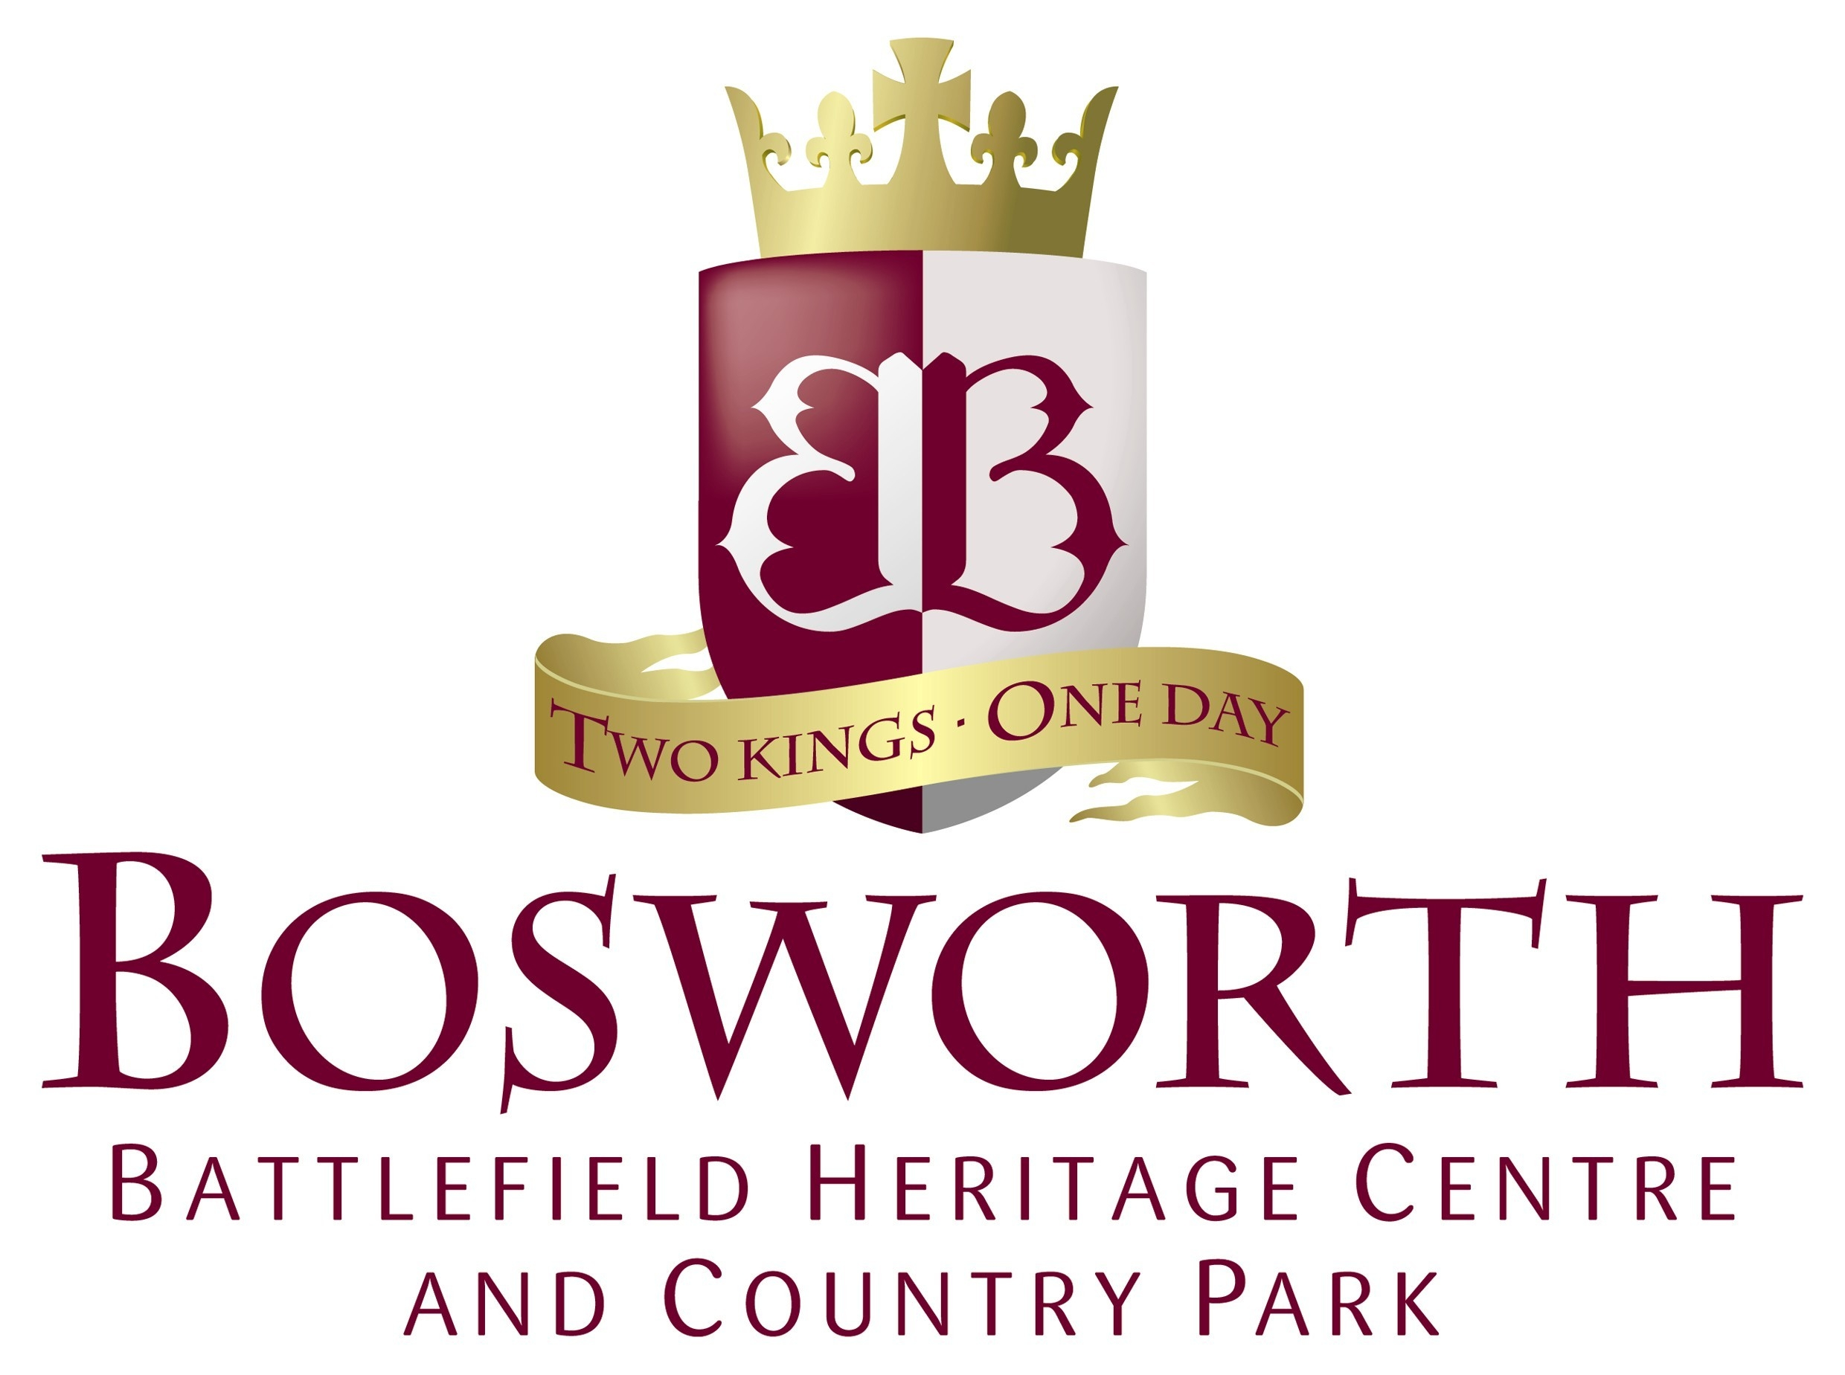
School Visits

Teacher Evaluation Form
We value your comments and opinions. Please take a little time to fill in the evaluation form below and email it to melissa.lewis@leics.gov.uk
2. Please complete the following table by ticking the following boxes:

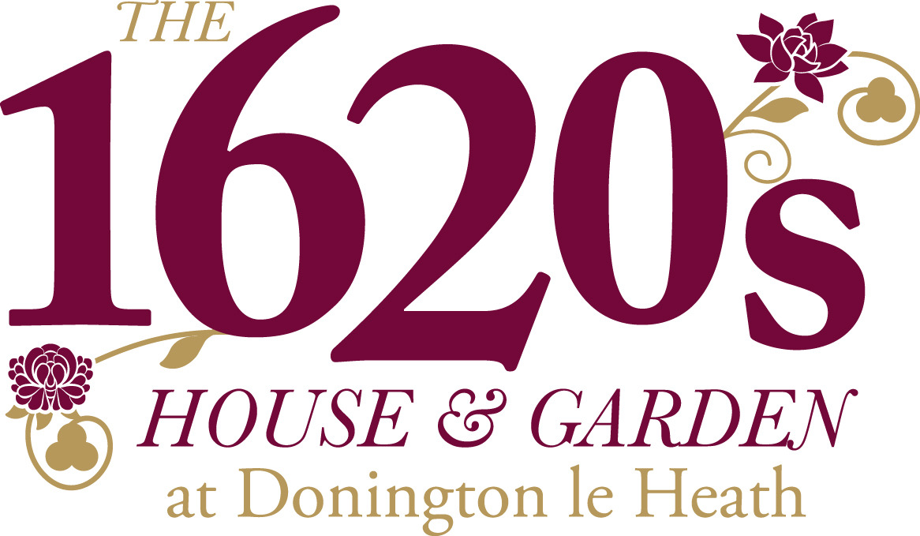
 | Strongly agree | Agree | Don’t know | Disagree | Strongly disagree
The quality of the teaching session(s) met my expectations
The visit increased pupils knowledge and understanding within the topic/area of study
The visit increased pupils practical and social skills
Pupils talked positively about their visit afterwards
The visit gave pupils opportunities to do things that they could not do in the classroom

About you

Name of School:…………………………… Visit date(s):…………………………

Name of contact:…………………………..

Which site did you visit? Please tick…..

Bosworth Battlefield 1620s House & Garden

About your learning experience
1. Please rate your overall experience of your school visit to the Museum:
1 2 3 4 5
lowest highest

P.T.O.
Add further comments:

About your visit
1. How would you rate the booking process?
1 2 3 4 5
lowest highest
Any comments?

2. How would you rate the education staff leading the sessions?
1 2 3 4 5
lowest highest
Any comments?

3. How would you rate the resources used in the session?
1 2 3 4 5
lowest highest

Any comments?

4. Any further comments?
For example, was it pitched to the correct level for your class?
Would you consider booking this session for another class in the future?
Did the activities engage your pupils?
Did the length and pace of the activities seem appropriate for your class?

Thank you for your time!

